Sharks Make Waves at Scottish National Age Group Championships
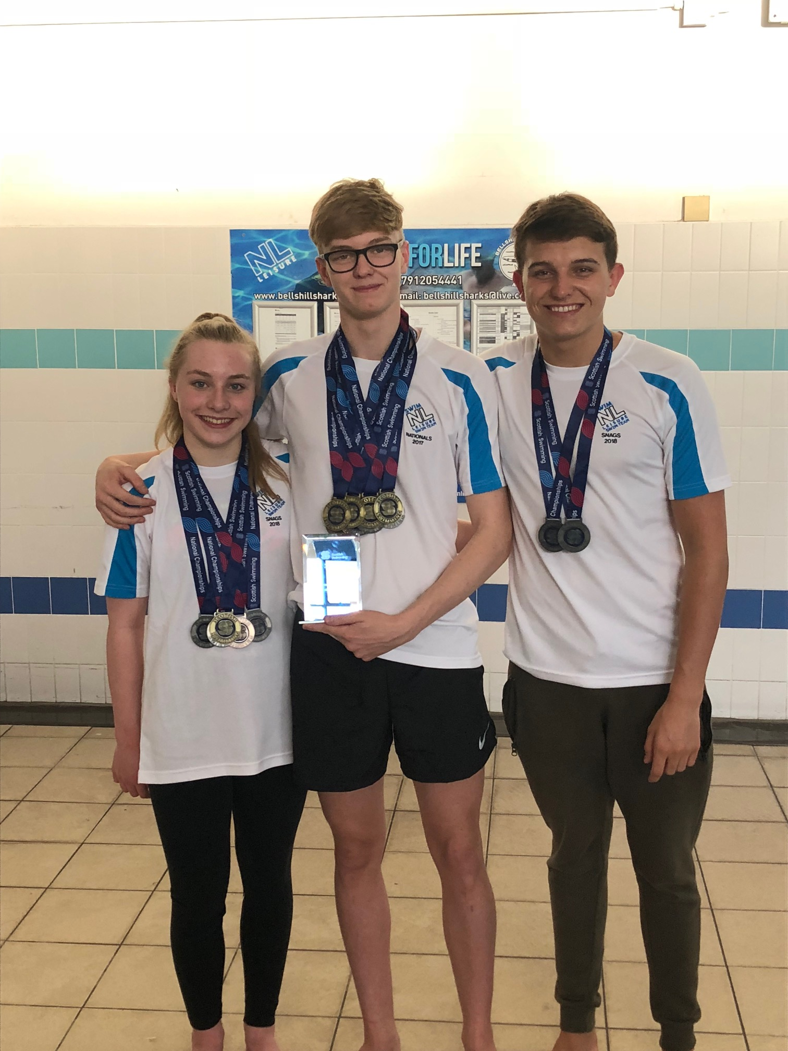
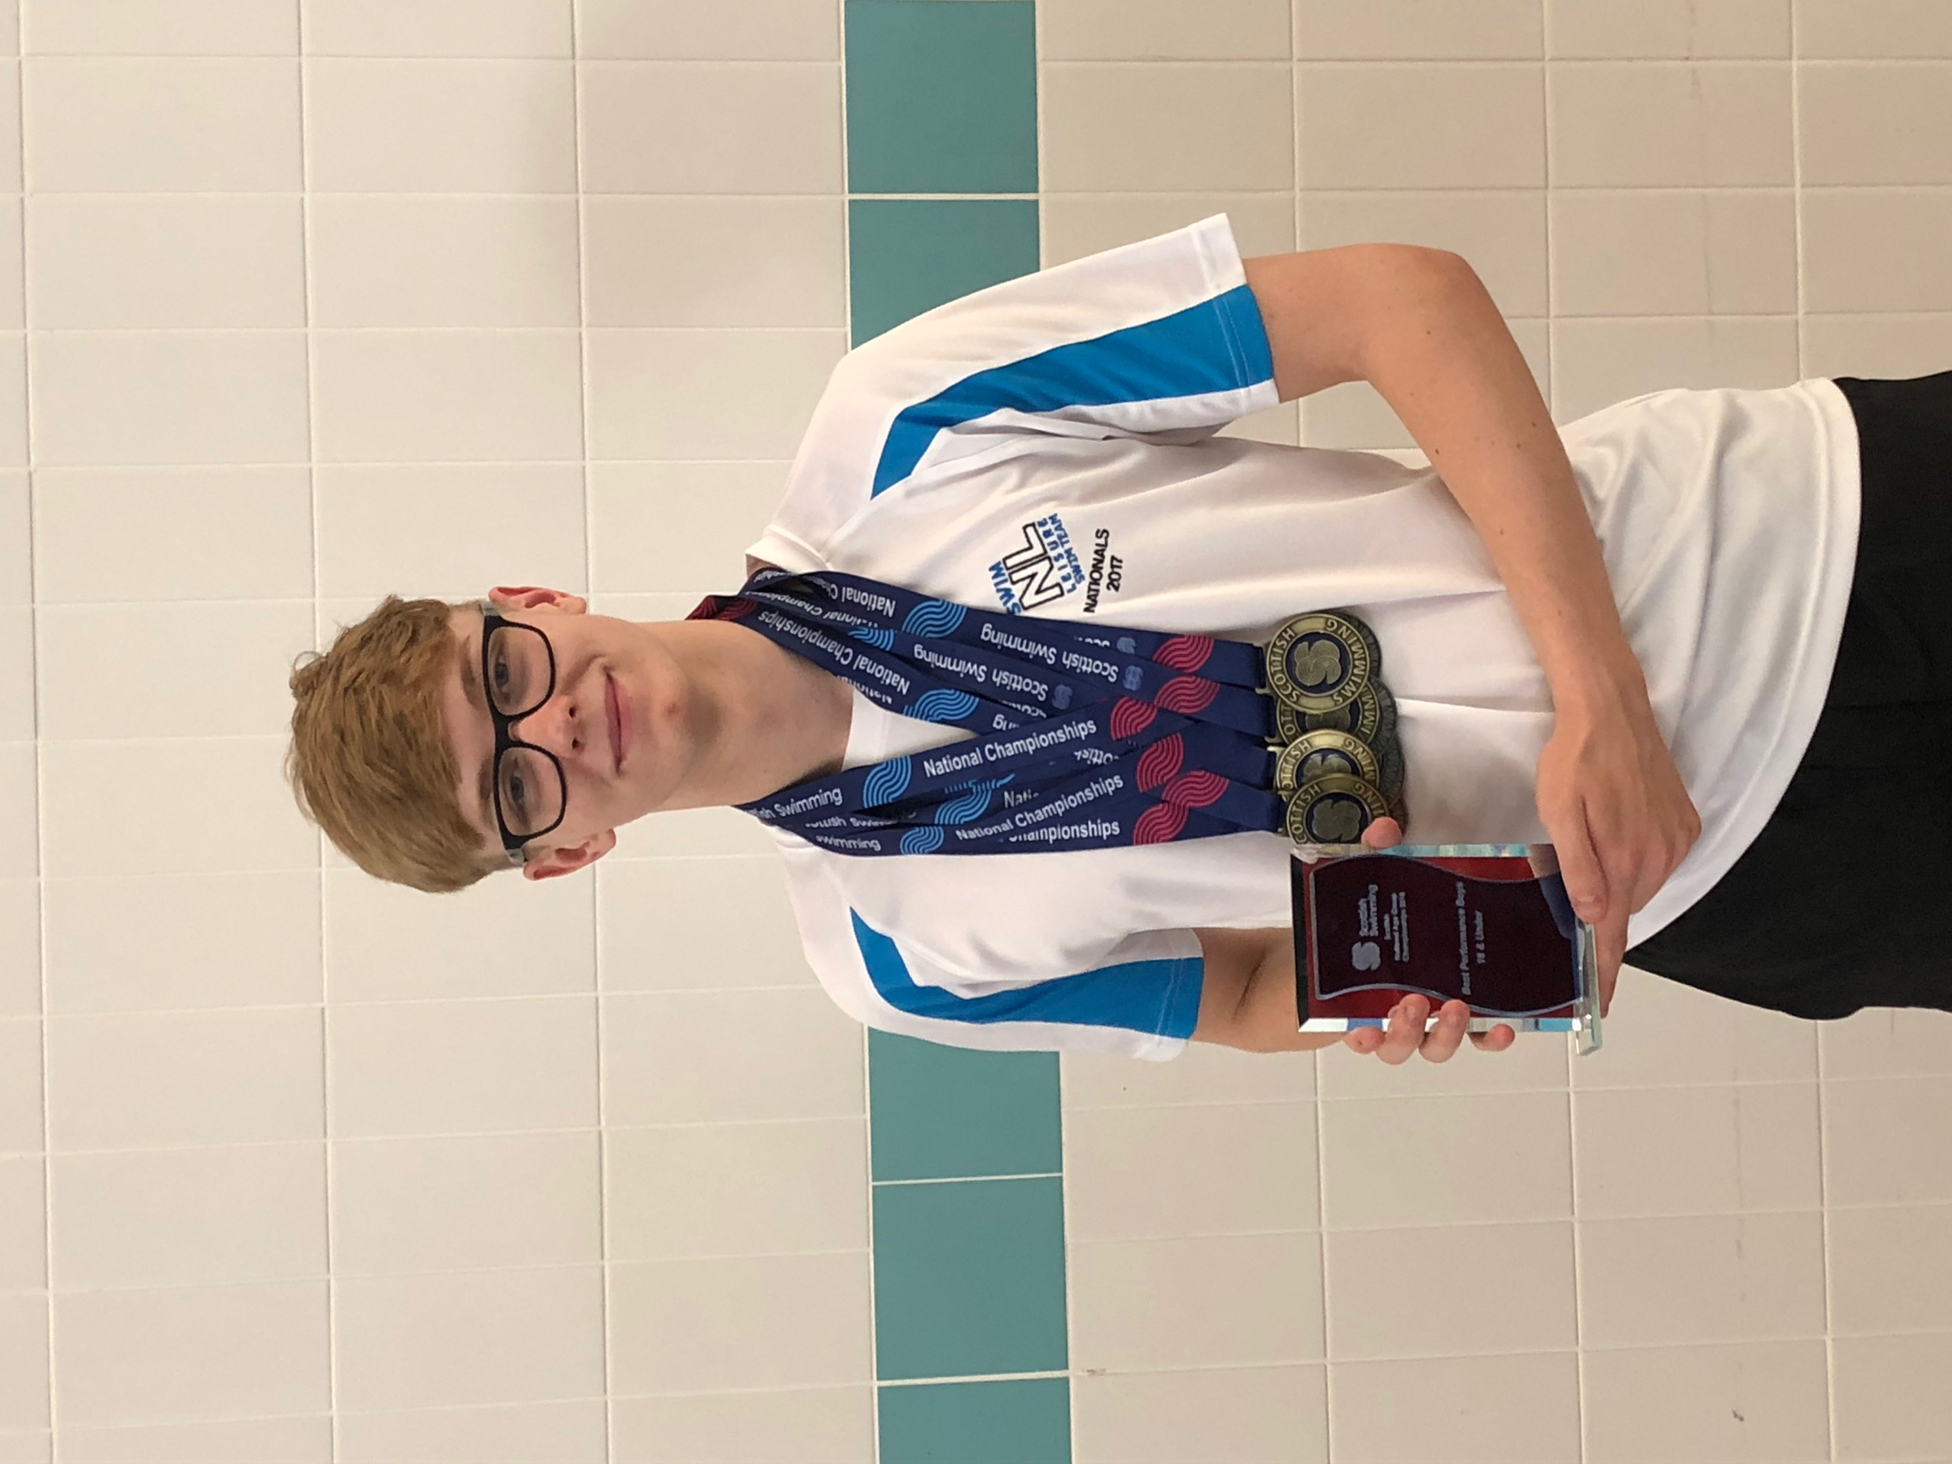

Bellshill Sharks swimmers recently competed at the Scottish National Age Group Championships at the International Swimming Centre, Tollcross over 5 days, 28th March to 1st April. This was a week of great success for the 16 swimmers who competed and won a grand total of 17 medals, 2 Scottish National Champions and had 37 top 10 finishes, one of the best hauls in recent years. Swimmers who competed; Greg Fairbairn, Giano Napolitano, Adam Airlie, Callum Warnock, Marijus Kringelis, Marc Devlin, Cameron Palmer, Jenna Cole, Millie Boyd, Louisa Carroll, Imogen Collins, Lia Heffernan, Erin Hughes, Carly Nimmo, Shannyn Reilly and Ella Stevenson.

Greg Fairbairn (16), won 4 x gold medals in the 200m Breaststroke, 100m Frontcrawl, 100m Breaststroke and the 200m Frontcrawl events, 3 x silver medals and 2 x bronze medals. Greg had a fantastic meet medalling in all events swam in and he also won the Best Swimming Performance for Under 18 Swimmer in the 200m Breaststroke event which topped off a hugely successful meet for the young swimmer who is in the Scottish Youth Squad.

Jenna Cole (13), had an amazing week becoming Scottish National Champion in the 800m Frontcrawl event as well as taking home 3 x silver medals and 1 x bronze medal during the meet. Jenna was pipped by just 8 one hundredths of a second in the 200m Frontcrawl final which was the closest event of the weeks swimming. This is a fantastic achievement for Jenna who started swimming lessons at the Sir Matt Busby Sports Centre in Bellshill before progressing through the learn to swim programme into the Bellshill Sharks. She has progressed through all squads from Development to their Junior Elite squad which shows the great work and desire from Jenna and the club to progress young swimmers.

Giano Napolitano (18) capped off a great weekend with 2 x silver medals in the 50m Butterfly and 400m Individual Medley and Adam Airlie (20), getting a 2nd place finish in the 50m Backcrawl event. All swimmers who competed in individual and relay events swam fantastic with lots of personal best swims and top 10 performances.

This has led to swimmers achieving swimming times in the window for selection for British Summer Championships and Scottish Summer National championships. With the window coming to a close the club have approximately 3 swimmers for British Championships and 15 for Scottish Summer Meet. Be sure to keep a look out for our young talented age group swimmers over the next coming months.

