Young Sharks Success at Graded Meets

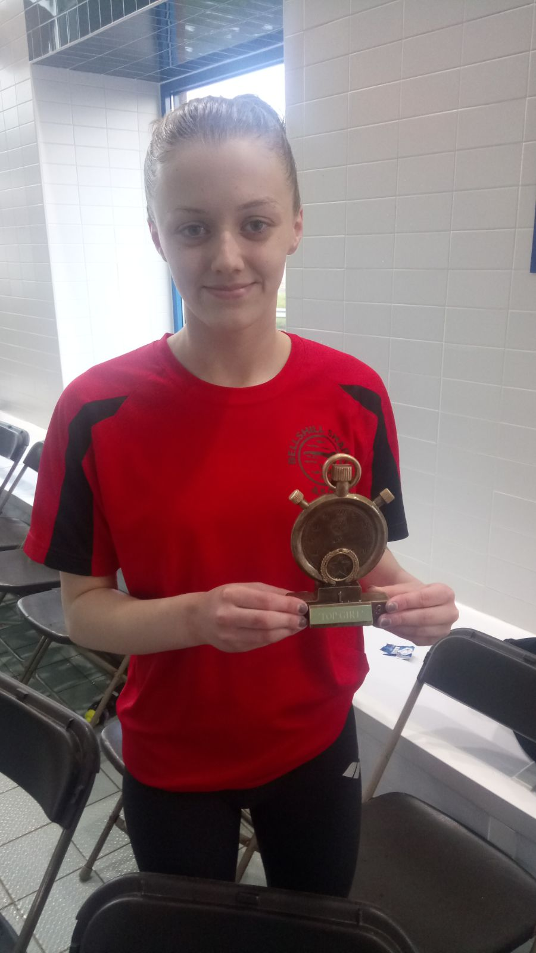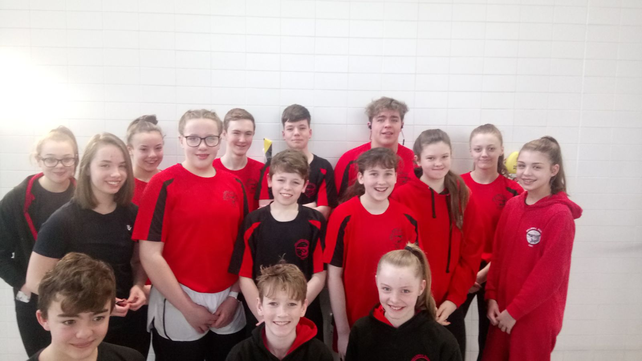

Young talented swimmers from Bellshill Sharks have had a successful few weeks at Graded Competitions; Cumbernauld Graded Meet, Falkirk Otters and City of Glasgow Graded Meets. We had great success across all three meets with some of our younger swimmers participating in their first competitions in short course (25 metre pools) and long course (50 metre pools). Swimmers accomplished 80% personal best swims over the course of these 3 weekends which is amazing for this time in the swimming season.

The swimmers achieved 66 top ten finishes at the Cumbernauld Meet, 20 top ten finishes at the City of Glasgow Graded Meet and 5 top ten finishes at Falkirk Otters meet. With 24 top three medals being won at Cumbernauld. This excellent performance saw Millie Boyd (14) achieving 4 golds and 2 silvers in her 6 swims at Cumbernauld which won her the Best Girl award of the weekend. Carly Nimmo also achieved a gold medal swim in the girls 15 years 100 breast stroke event at City of Glasgow Graded Meet. Our second medal swim of the weekend came from Cameron Palmer in the 100m back crawl event in a very good seasons personal best. Our 11 and under swimmers who competed at Falkirk Otters posted amazing swims and personal best times.

This builds on what has been a very good start to our swimming season and gives the swimmers lots to build on over the rest of the season with District and National events coming up over the coming months. We hope that people from around the local area can continue their support for Bellshill Sharks and follow our progress within the swimming season.

